JavaScript Data Types Reference Guide

Primitives are still primitive. A single value, as desired.
The language allows access to methods and properties of strings, numbers, booleans and symbols.
In order for that to work, a special “object wrapper” that provides the extra functionality is created, and then is destroyed.

The “object wrappers” are different for each primitive type and are called: String, Number, Boolean, Symbol and BigInt. Thus, they provide different sets of methods.

Numbers:
//all are correct
let billion = 1000000000;
let billion = 1_000_000_000;
let billion = 1e9;

also, 1e-4 == 0.0001 etc

0x is the shorthand for hex numbers
ex: 0xff == 255 //case doesn't matter

Likewise, 0b and 0o are used for binary and octal numeral systems
so, 0xff == 0b11111111 == 0o377 == 255

num.toString(base) converts a number into a string of the corresponding base system
base can range from 2-36
base 36 can shorten a very long number ex: 123456..toString(36) == 2n9c
NOTE: when applying a method onto a number, 2 dots ".." are needed to differentiate from a decimal point OR (123456).toString(36) can be used

Converting to integer:
Math.floor
Rounds down: 3.1 becomes 3, and -1.1 becomes -2.
Math.ceil
Rounds up: 3.1 becomes 4, and -1.1 becomes -1.
Math.round
Rounds to the nearest integer: 3.1 becomes 3, 3.6 becomes 4, the middle case: 3.5 rounds up to 4 too.
Math.trunc (not supported by Internet Explorer)
Removes anything after the decimal point without rounding: 3.1 becomes 3, -1.1 becomes -1.
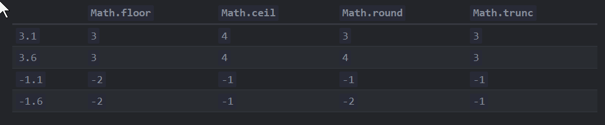

To allow a specified number of decimal points, multiply, round, divide
let num = 1.23456;
alert( Math.round(num * 100) / 100 ); // 1.23456 -> 123.456 -> 123 -> 1.23

num.toFIxed(numberOfDecimals) rounds value and returns string (with added zeros if needed)
can use +num.toFIxed(#) for number
this can round incorrectly due to precision loss, so be careful

Because JavaScript stores numbers by converting them into binary equivalents, fractions/decimals can have weird impressions. You can mitigate this with the multiply, then divide trick, but that's still not perfect. It's best to use rounding and/or toFixed as needed

The way JavaScript stores number also results in 2 zeros: 0 and -0, but they are treated the same

isNaN(value) converts its argument to a number and then tests it for being NaN
NaN is unique in that it doesn't equal anything else, including itself
isFinite(value) converts its argument to a number and returns true if it’s a regular number e.g. not NaN/Infinity/-Infinity
used to check inputs are simple numbers ex:
let num = +prompt("Enter a number", '');
// will be true unless you enter Infinity, -Infinity or not a number
alert( isFinite(num) );
NOTE: an empty or a space-only string is treated as 0 in all numeric functions including isFinite.

Number.isNaN(value) checks if the value is of the type number and it is NaN, strings return false
Number.isFinite(value) check if the value is of the type number and is not NaN, infinity, or -infinity, all strings, even those of use numerals, return false

Object.is(a,b) called SameValue is mostly equivalent to === except for NaN, where Object.is(Nan,Nan) === true but Object.is(0,-0) === false

parseInt and parseFloat will pull the first numeric values from a string containing additional characters after the number
alert( parseInt('100px') ); // 100
alert( parseFloat('12.5em') ); // 12.5
alert( parseInt('12.3') ); // 12, only the integer part is returned
alert( parseFloat('12.3.4') ); // 12.3, the second point stops the reading
alert( parseInt('a123') ); // NaN, the first symbol stops the process

NOTE: parseInt can also convert from alternate bases
alert( parseInt('0xff', 16) ); // 255
alert( parseInt('ff', 16) ); // 255, without 0x also works
alert( parseInt('2n9c', 36) ); // 123456

Additional math functions:

Math.random() //Returns a random number from 0 to 1 (not including 1).

Math.max(a, b, c...) and Math.min(a, b, c...) //Returns the greatest and smallest from the arbitrary number of arguments.

Math.pow(n, power) //Returns n raised to the given power.

more can be found here:
https://developer.mozilla.org/en-US/docs/Web/JavaScript/Reference/Global_Objects/Math

Strings:
let single = 'single-quoted';
let double = "double-quoted";
let backticks = `backticks`;

`1 + 2 = ${sum(1, 2)}.` //1 + 2 = 3.

NOTE: it is possible to create string templates, check MDN documentation if needed

let guestList = `Guests:
* John
* Pete
* Mary
`; // is a string that spans multiple lines, even when printed

Special characters: start with \ (called escape character)
\n indicates a new line
\t indicates a tab
\', \", \` quote characters
\\ backslash character

ex: let guestList = "Guests:\n * John\n * Pete\n * Mary"; //is the same as above string

NOTE: if you use a different string notation method than the one you need to represent, you can avoid escape characters
ex: "I'm the Walrus!"

stringName.lenth //it's a property, not a method
//escape character isn't counted, but the character after it is (including \n)

stringName[pos] //pos is the position of the desired character within the string, starting with 0
stringName.at(pos)
stringName.at(-pos) //counts from the end of the string, starting with 1
//stringName[stringName.length - pos] does the same thing

Strings are immutable, so you can't edit their structure without assigning them to a new string

stringName.toUpperCase();
stringName.toLowerCase();
both can be applied to a single character stringName[pos].toLowerCase(), but will only return that single character

Searching within a string
stringName.indexOf(subString [, startingPosition]) //only first parameter is required
//returns index of first character if found, -1 if unfound
**is case-sensitive**
stringName.lastIndexOf(subString [, staringPosition]) //starts at startingPosition and works backwards (still returns first position of first character)
NOTE: "canal".lastIndexOf(""); // returns 5

To check for the presence of a substring using an if statement, you can't just use "if (str.indexOf("Widget"))" because it would return 0, which converts to false so:
let str = "Widget with id";
if (str.indexOf("Widget") != -1) {
alert("We found it");
OR
stringName.includes(substring [, startingPosition]) //returns boolean
ALSO
"Widget".startsWith("Wid")
"Widget".endsWith("get")

Getting Substrings:
str.slice(startPosition [, endPosition]) //return doesn't include endPosition
//neg positions work as long as the "start" is farther right
str.substring(Position1 [, Position2]) //same as slice, but will start with the smaller argument
//does not support neg positions (treated as 0)
str.substr(start [, length]) //same as .slice(), but with optional length instead of end position
NOTE: substr() exists in AnnexB, so may not be supported in server-side engines

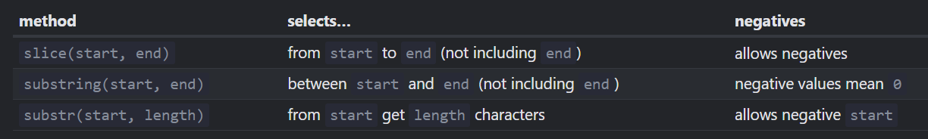

str.codePointAt(pos) //returns UTF-16 number code for character at pos
ex: alert( "Z".codePointAt(0) ); // 90
alert( "z".codePointAt(0) ); // 122
alert( "z".codePointAt(0).toString(16) ); // 7a (if we need a hexadecimal value)

String.fromCodePoint(code) //creates a character by its numeric code
ex: alert( String.fromCodePoint(90) ); // Z
alert( String.fromCodePoint(0x5a) ); // Z (we can also use a hex value as an argument)

Because basic, direct string comparisons are complicated, use:
str.localeCompare(str2)
- Returns an integer indicating whether str is less, equal or greater than str2 according to the language rules:
  - Returns a negative number if str is less than str2.
  - Returns a positive number if str is greater than str2.
  - Returns 0 if they are equivalent.
- ex: alert( 'Österreich'.localeCompare('Zealand') ); // -1

str.trim() //removes (“trims”) spaces from the beginning and end of the string.
str.repeat(n) //repeats the string n times.

str.split(delim) //splits the string into an array by the given delimiter delim
//usually " " or "," or ", "
//has optional second argument of max array length

Blue Doc Hudson Toy Cars?

Code:

function readNumber() {
let num;

do {
num = prompt("Enter a number please?", 0);
} while ( !isFinite(num) );

if (num === null || num === '') return null;

return +num;
}

alert(`Read: ${readNumber()}`);

RANDOM NUMBER GENERATORS:
function random(min, max) {
return min + Math.random() * (max - min);
}

function randomInteger(min, max) {
// now rand is from (min-0.5) to (max+0.5)
let rand = min - 0.5 + Math.random() * (max - min + 1);
return Math.round(rand);
}

function randomInteger(min, max) {
// here rand is from min to (max+1)
let rand = min + Math.random() * (max + 1 - min);
return Math.floor(rand);
}

Finding all instances of a subString:
let str = 'As sly as a fox, as strong as an ox';
let target = 'as'; // let's look for it

//use this
let pos = 0;
while (true) {
let foundPos = str.indexOf(target, pos);
if (foundPos == -1) break;

alert( `Found at ${foundPos}` );
pos = foundPos + 1; // continue the search from the next position
}

//OR this
let pos = -1;
while ((pos = str.indexOf(target, pos + 1)) != -1) {
alert( pos );
}

function ucFirst(name){
if (!name) return name;
if (!isNaN(name)) return name;
return name[0].toUpperCase() + name.slice(1);
}

function checkSpam(str) {
if (!str) return false;
if (!isNaN(str)) return false;

let lowerCaseStr = str.toLowerCase();

if (lowerCaseStr.includes("viagra") ||
lowerCaseStr.includes("xxx")) {
return true;
}
return false

}

